Bitless Equestrian Centre – Talsarn – SA48 8RA

Fitting & using a crossover (Dr Cook style) bitless bridle
With grateful thanks to Dr Robert Cook who researched & pioneered the crossover Bitless Bridle and as a result many thousands of horses no longer suffer pain & discomfort associated with having a bit in their mouth
Safety - Sound physiological arguments indicate that a crossover (cross-under) bitless bridle is safer than the bit method of control. Experience with the bridle (specifically the Dr Cook Bitless Bridle) since 1997 supports this statement. Nevertheless, equitation is an inherently risky activity and Bitless Equestrian Centre can accept no responsibility for any accidents that might occur.
Caution When using for the first time, begin in a school or a small paddock rather than an open area. We recommend that horses are firstly long-lined in any new item of tack to help them to familiarise themselves with it and to reduce the small risk of boisterous behaviour, (which happens in less than 1% of horses) before the rider mounts.
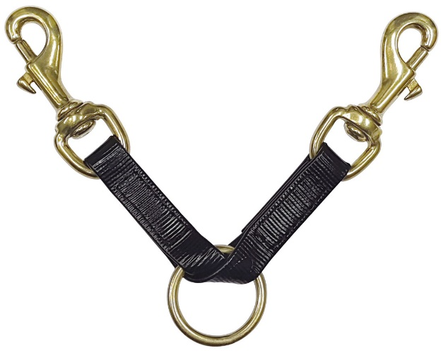
To facilitate safe use of a single lunge line with a bitless bridle we offer this lunge strap attachment with 2 brass clips and a brass O ring. The lunge strap is also very useful to attach a lead rope or lunge line to a bitless bridle, whilst someone is riding and holding the reins. The lunge strap also makes it easy to safely tie and lead with a bitless bridle. Never tie your horse using crossover straps!
The action of a crossover bitless bridle (also known as crossunder) differs fundamentally from other bitless bridles (the hackamores, bosals and sidepulls which use direct pressure). The crossover (crossunder / Dr Cook style) bitless bridle uses indirect pressure; the figure of eight configuration of the crossover straps distributes gentle pressure around the whole of the head – Dr Cook describes it as a ‘whole head hug’ – many horses go very well in this type of bitless bridle, as we found through the many, many years of using Dr Cook Bitless Bridles in our riding school. Unlike the bit method of control, the crossover bitless bridle is compatible with the physiological needs of the horse at exercise. First and foremost, it does not injure or frighten the horse, but neither does it interfere, as does the bit, with the horse’s ability to breathe and stride freely.
Steering: A squeeze on one rein pushes inoffensively but persuasively on the opposite half of the head. Where the head goes, the horse follows. Horses respond better to being pushed than pulled. They also prefer to receive the aids distributed painlessly over a large area of the head than painfully and focally in the mouth which is an exquisitely sensitive area.
Braking: A squeeze on both reins hugs the whole of the head and triggers a ‘submit’ response. This applies more effective brakes than those provided by a bit. The crossover / crossunder bitless bridle provides communication by applying painless pressure across the poll, behind the ears (a region of particular responsiveness), down the side of the face, under the chin and across the nose.
The aids: are the same as with the bit method of control. From the rider’s perspective there is very little difference in the way you communicate with your horse, though you will probably eventually discover that you can ride with a lighter, more subtle hand. Most horses (and riders) take to a bitless bridle on the very first day. They do not require weeks of adjustment.
Sometimes a rider has focussed too much on the bit to control, but a bitless bridle not only frees the horse from the bit itself, but frees the rider from relying on it. A few riders have reported that, at first, the horse feels a little heavier in the hand than with a bit but this soon passes. In effect, the horse becomes lighter on the forehand and most riders sense that the horse becomes more collected. We always recommend a horse is first long-lined in any new piece of tack before being mounted. Riders should strive for light contact and an independent seat.
The reins should not normally be used as a safety harness and the means whereby riders retain their seat or restore their balance. Nevertheless, if it should become necessary, the reins can be used in this way without hurting the horse. Bitless bridles provide ‘brakes’ that are better than a bit. Unlike the bit method of control, which causes pain (bear in mind that a horse’s primary instinct is to flee from pain) and which the horse can disable by placing the bit between its teeth, at no time can the rider be left without any brakes at all. Horses bolt because of fear or pain. By removing the bit, the rider has eliminated one of the most common sources of fear and pain, although pain in areas other than the mouth can still be responsible for bolting.
For example, pain in the back or feet (from saddle or shoes) should be considered. It is not recommended that riders attempt to stop a runaway horse by simply hauling on both reins at the same time. If equitation ever comes to a trial of strength, the horse is going to win. If, when using a bitless bridle, a horse should ever show signs of bolting, the rider can regain control by steering the horse into a circle. If this is not possible because of the surroundings, then the rider can use the reins alternately to bring the horse back into control. Unlike the situation when using a bit, this rapid alternate traction on left and right rein (also referred to as “rattling” or “shaking” the reins) can be done without hurting the horse. Apply this aid vigorously and with authority to get your horse’s attention. Remember also to sit back, deep in the saddle. Finally, all horses should be trained to respond to a verbal “WHOA!”

Fitting a crossover bitless bridle
Step 1: Unbuckle the chinstrap at the back of the noseband, leaving all other buckles fastened, and spread open the noseband. Slip the bridle over the horse’s ears much like a normal bridle, making sure the cross-under straps go under the jaw and the noseband is over the nose. Loosely buckle the chinstrap, it will be tightened correctly later.
Step 2: Adjust the noseband so that the lower edge of the noseband sits approximately 1.5 to 2 inches above the corner of the mouth.
Step 3: Adjust the crossovers so that there are at least 3 inches of cross-under strap between the ring on the noseband and the attachment ring for the reins
Step 4: Tighten the chinstrap buckle until you can just get one flat finger under the chinstrap. Make sure you have not trapped either of the cross-under straps under the chinstrap. Step 5: Attach your reins to the O-rings on the ends of the crossover straps. Check that the browband sits comfortably and is not pinching the base of the ears.
Once the bridle is properly adjusted, the chinstrap is the only buckle you need to release to bridle or unbridle your horse.
Fitting problems: Occasionally we hear that the bridle does not seem to be effective on their particular horse. Issues include problems with steering, problems with stopping and headshaking or other indications of discomfort. These issues can be caused by the following:
1. The chinstrap is too loose. Tighten the chin strap so that only one flat finger can be comfortably inserted between the underside of the jaw and the chin strap. The chin strap should be sufficiently snug so that the headstall does not slide when rein traction is applied. If this happens, leverage will be lost and skin abrasion could develop. One sign of the noseband being too loose is that the cheek straps of the headstall bow out prominently when pressure is applied via the reins. Some slight bowing is normal, but if the bowing extends out two inches or more from the face, an adjustment to the chinstrap is needed.
2. The noseband is not low enough. The correct placement of the noseband is lower than most other bridles. Placing the noseband too high will result in some loss of communication, which can cause problems with steering and stopping. We recommend placing the noseband 1.5 to 2 inches above the corner of the mouth.
3. The noseband is too low. Occasionally a horse will show discomfort when the noseband is placed at the recommended position of 1.5 to 2 inches above the corners of the mouth. If this occurs, first try using less rein pressure. Secondly, try moving the noseband up a little. Your level of communication is reduced as the noseband is raised, but this may be just what the horse needs. It is important to make sure that the noseband is supported by bone and not placed so low that it is supported by the soft fleshy part of the nose. If placed too low, the noseband will obstruct the nostrils and could cause head shaking or even rearing.
Other problems: Teeth with sharp edges: The crossover straps of a bitless bridle put pressure along the horse’s cheek, which may press against the sharp edges of teeth. This problem can be solved by your equine dentist.
Other pain or discomfort: With the pain of the bit removed, your horse may become more aware of other painful problems such as a poorly fitted saddle or shoeing / hoof trim problems. Try riding or lunging your horse bareback to determine if your saddle is a source of trouble. You may want to consider switching to a barefoot trim for your horse to eliminate metal from your horse’s feet as well as from their mouth.
Habitual behaviour: Your horse may be accustomed to using any one of a number of bit-aversion techniques to override your ability to communicate. The crossover bitless bridle’s communication cannot be evaded, and some horses may become frustrated and throw a bit of a temper tantrum when they realise they no longer control the show. Patience and groundwork will eventually teach your horse to accept your cues. There are numerous other less common reasons why your horse may not respond correctly to a bitless bridle.
If you have problems with your horse in any of our bitless bridles, please message us via our WhatsApp Business 01570 471541 or email sheil@bitlessbridle.biz. We will work with you to try to find a solution.

Bitless Equestrian Centre

sheil@bitlessbridle.biz
WhatsApp 01570 471541

